**R installation steps**

**FRE 501**

For your assignments in FRE 501, you will be programing in R, and for that you will need the desktop version of R.

The program is called “R Studio” and R Studio allows you to create R files and markdowns in a interactive environment.

You have to install R and then R studio.

Steps:

1. Installing R: Go to this (<https://cran.r-project.org/>) link and download R by clicking on the link that is relevant to your OS. Eg: If you have Windows, then click on “Download R for Windows”
   1. Then click on “Install R for the first time”
   2. Click on “Download R-4.4.1 for Windows”
2. Double-click to open the file you have just downloaded and then keep clicking “next”. Keep all the default and/or recommended settings.
3. 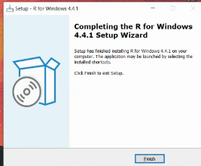

This confirms that you have installed R

1. Now you have downloaded R. This also has an interface and can run R scripts. Now, we will download R Studio, an IDE to program in R.
2. Installing R studio: <https://posit.co/download/rstudio-desktop/> and download the link based on the OS you have:

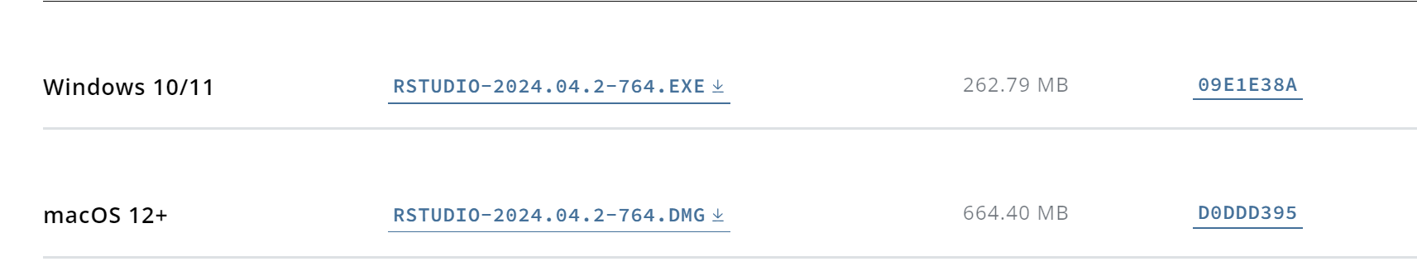

1. Follow the same steps as before to install R Studio (open the file, keep the default settings)
2. After installation, open the RStudio app. When this dialogue opens up, click “OK”

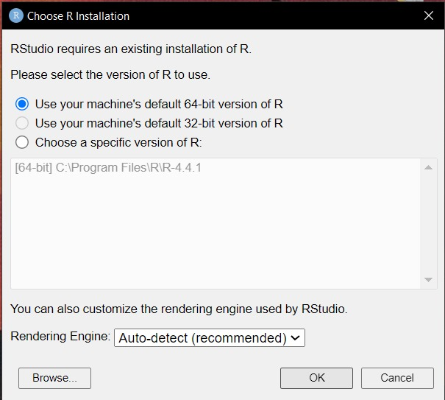

1. This screen confirms that all installations have been done correctly:

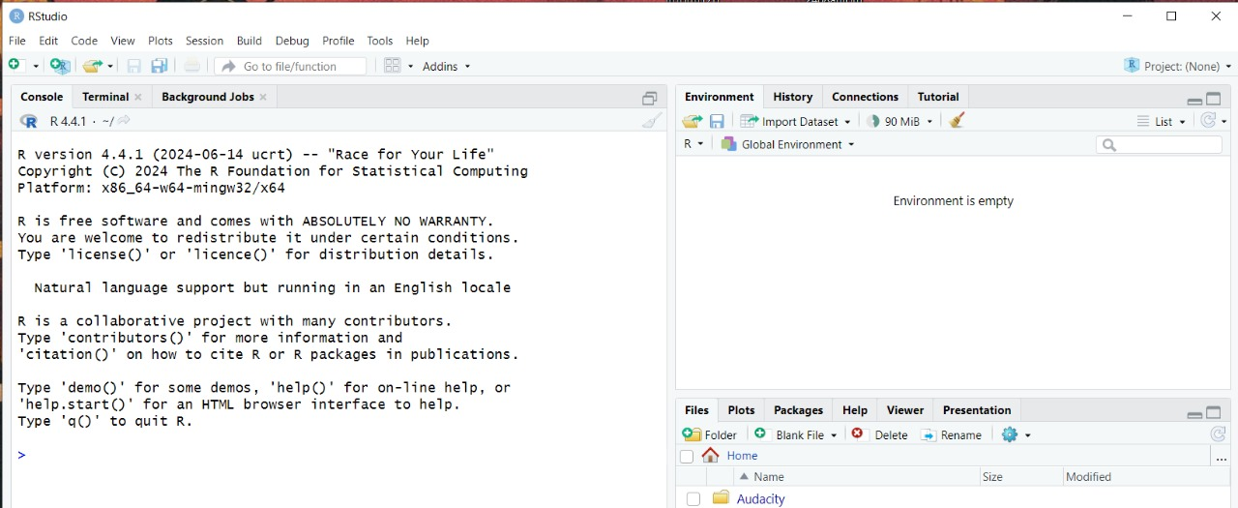

1. Try some basic commands to test whether R has been installed correctly:

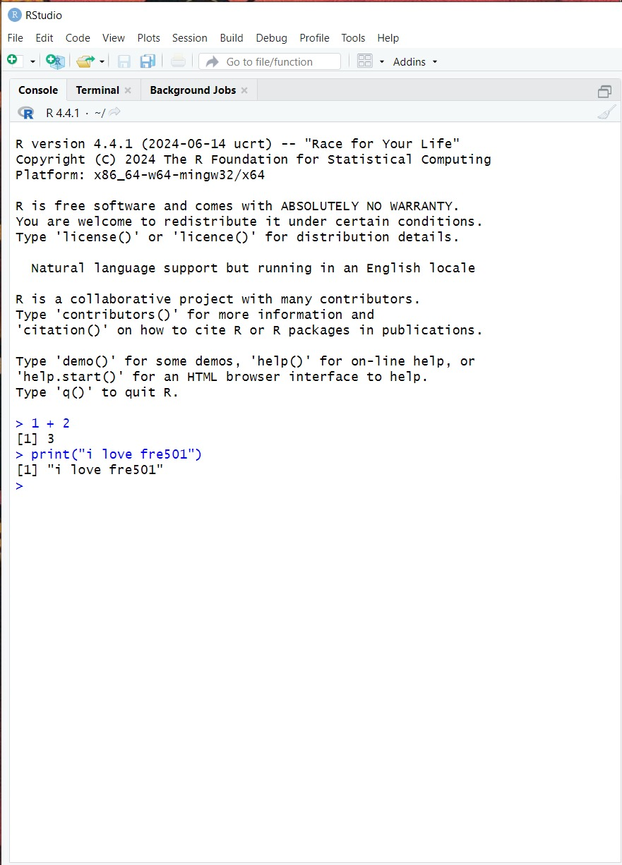

Happy coding!

Resources:

https://rstudio-education.github.io/hopr/starting.html